DVA LAB EXAM

**NAME :- M Shrawan Matrubai**

**USN :- 1BM21AI062**

**QUESTION – 3**

**Multivariate Analysis**

STEP 1-> OPEN JMP SOFTWARE

->CLICK ON HELP ->SAMPLE DATA FOLDER ->DATA SET

-> OPEN ANY DATABASE FROM THE GIVEN AVAILABLE DATABASE .EX- SOCIO ECONOMIC DATABASE

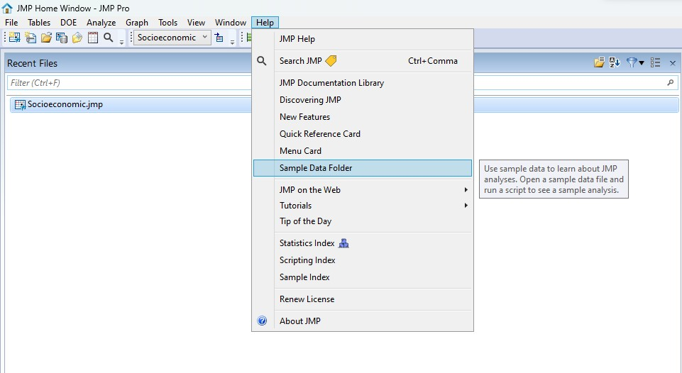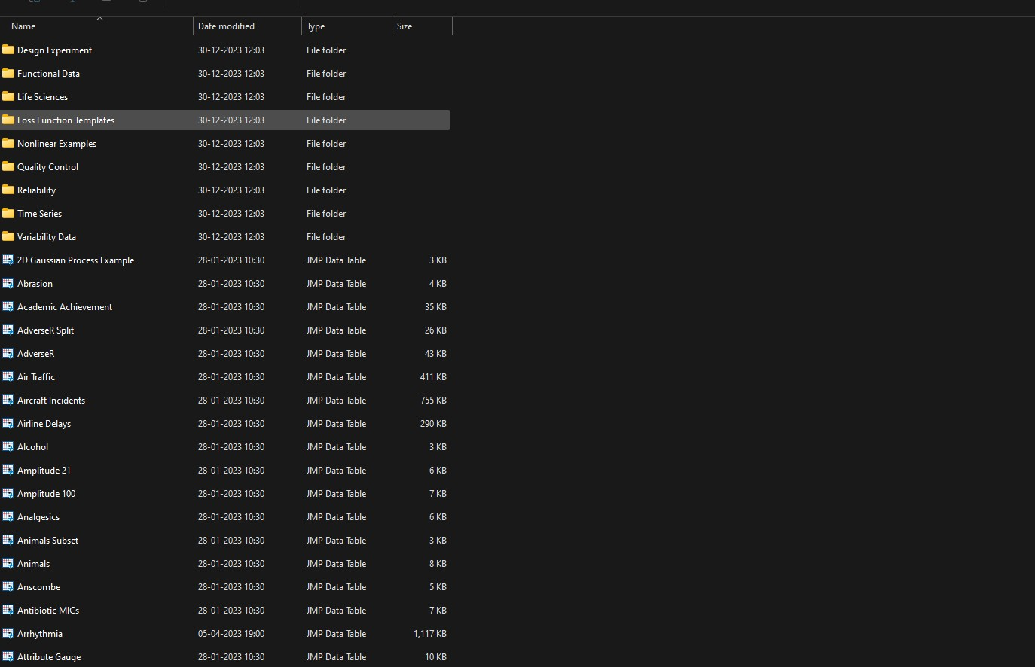

Step 2:- you will find the desired dataset on the jmp software

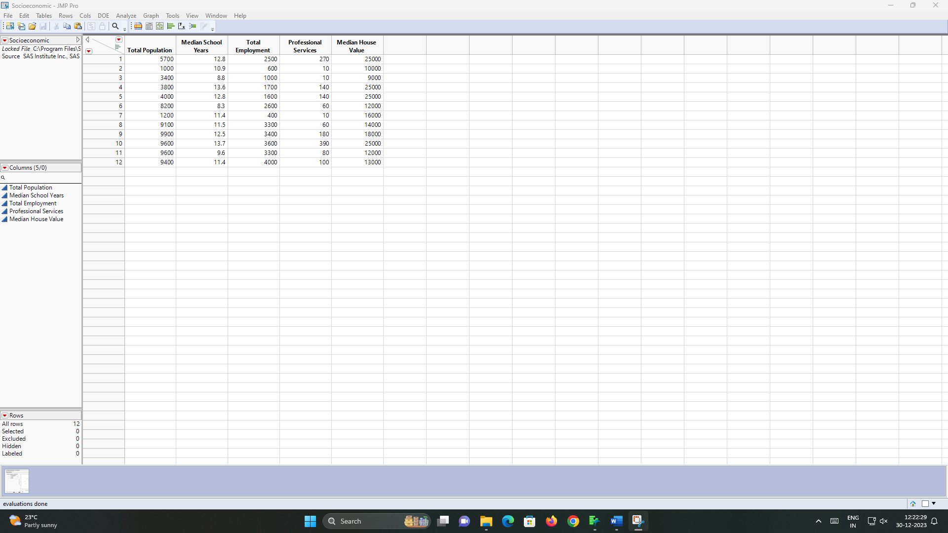

Step3:- click on analyse and then click on multivariate methods

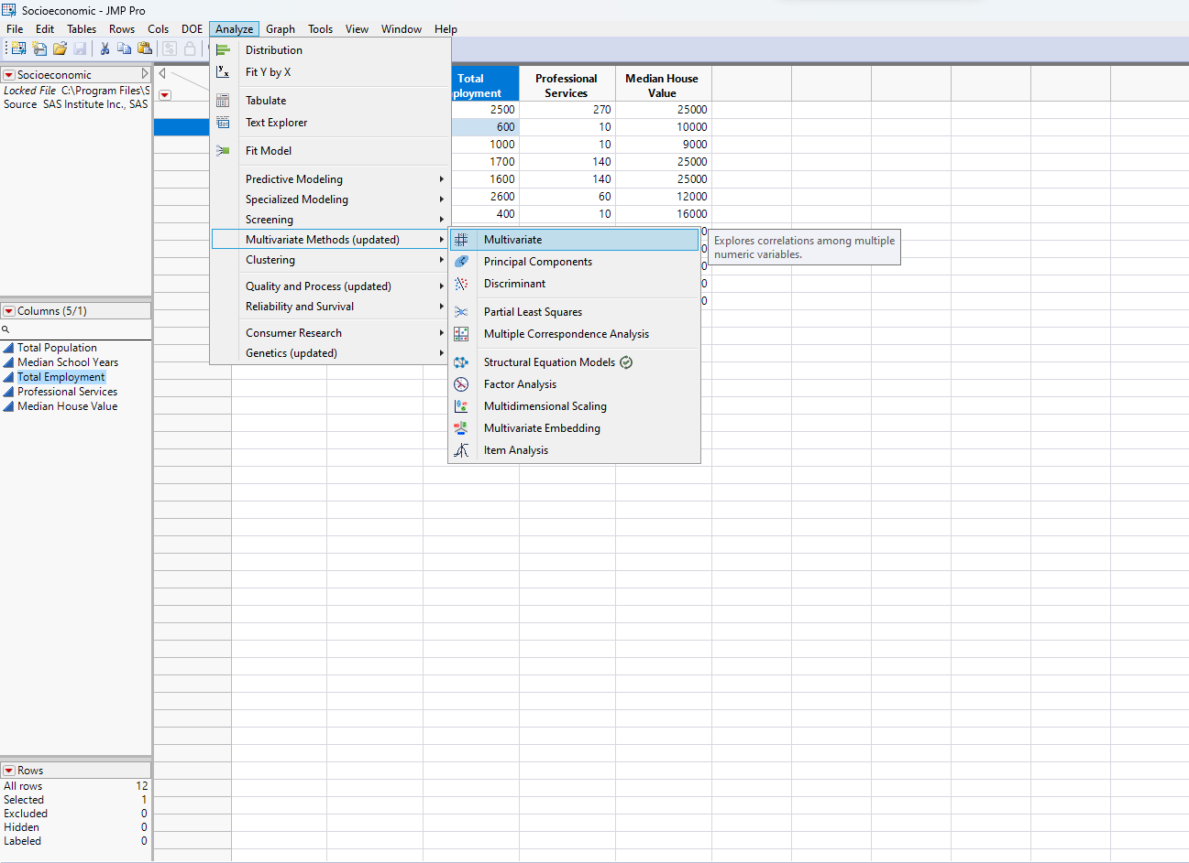

Step 4:- -> FOR MULTIVARIATE ANALYSIS OUTPUT

->CLICK ON MULTIVARIATE AND PASTE ALL THE COLUMNS IN THE Y-AXIS TO GET MULTIVARIATE ANALYSIS OUTPUT

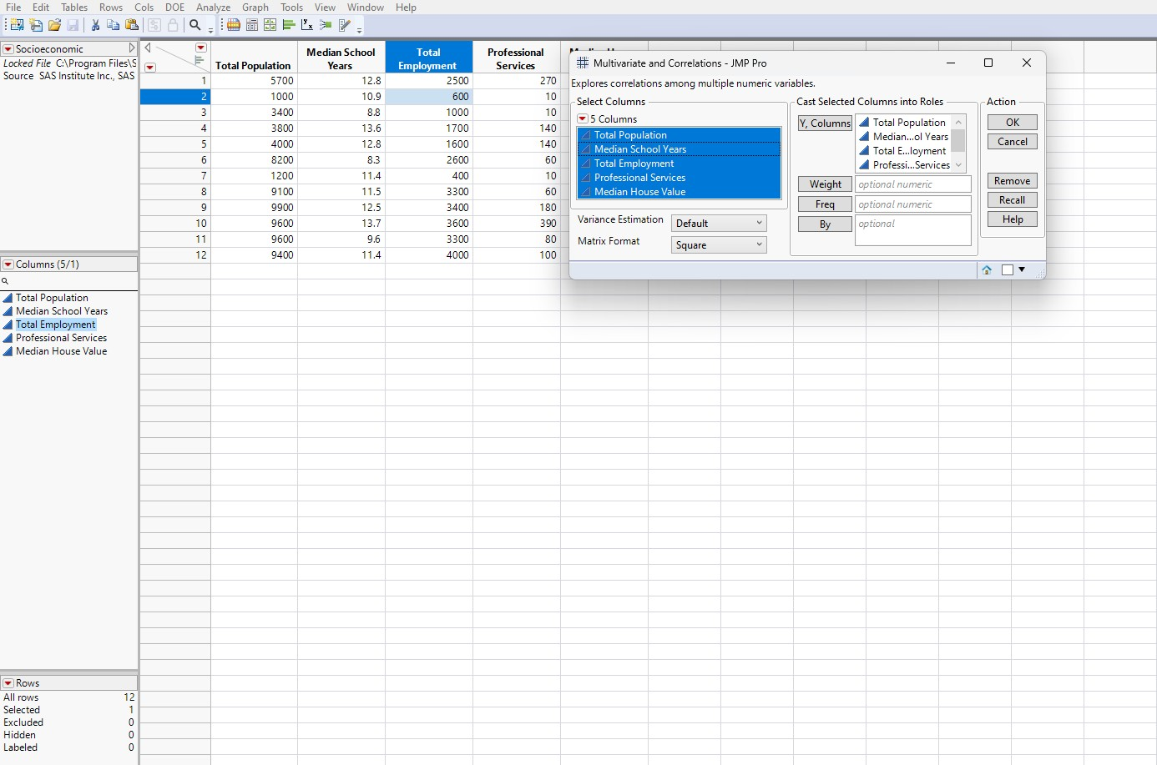

MULTIVARIATE OUTPUT

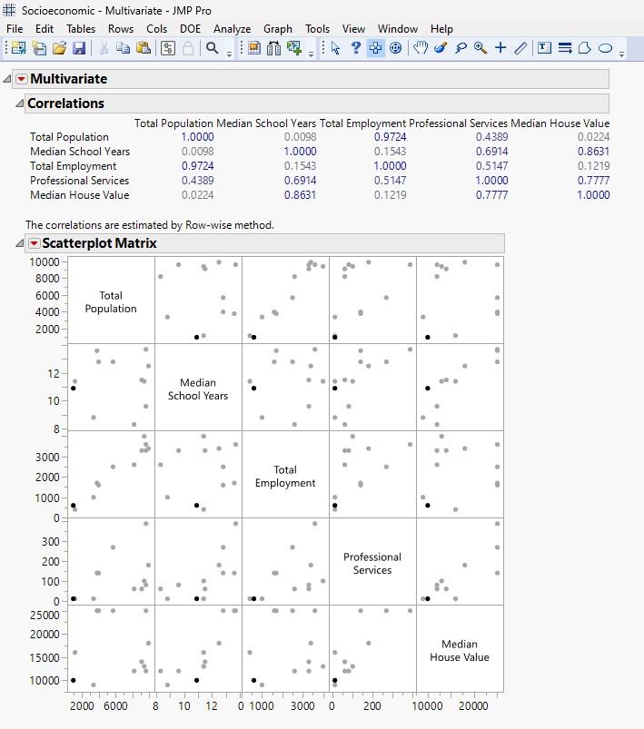

# ➔ STEPS TO GET PRINCIPLE COMPONENT ANALYSIS (PCA ) OUTPUT

STEP 1:- CLICK ON ANALYSE ->MULTIVARIATE METHODS ->PRINCIPLE COMPONENT ANALYSIS TO GET PCA OUTPUT

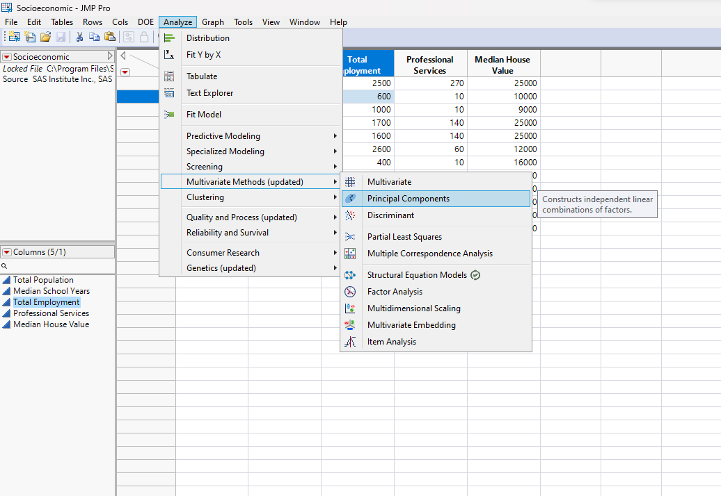

# ➔ STEPS TO GET FACTOR ANALYSIS

STEP 1 -> CLICK ON ANALYSE ->MULTIVARIATE METHODS -> FACTOR ANALYSIS TO GET THE OUTPUT

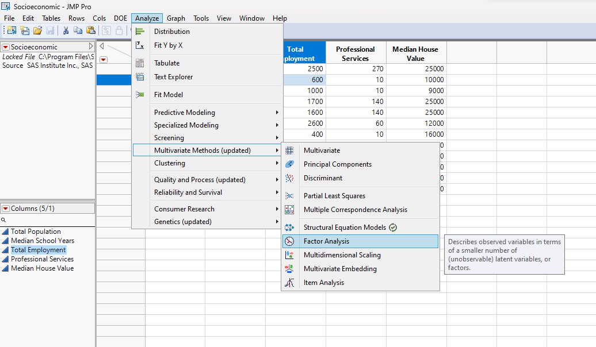

# FACTOR ANALYSIS

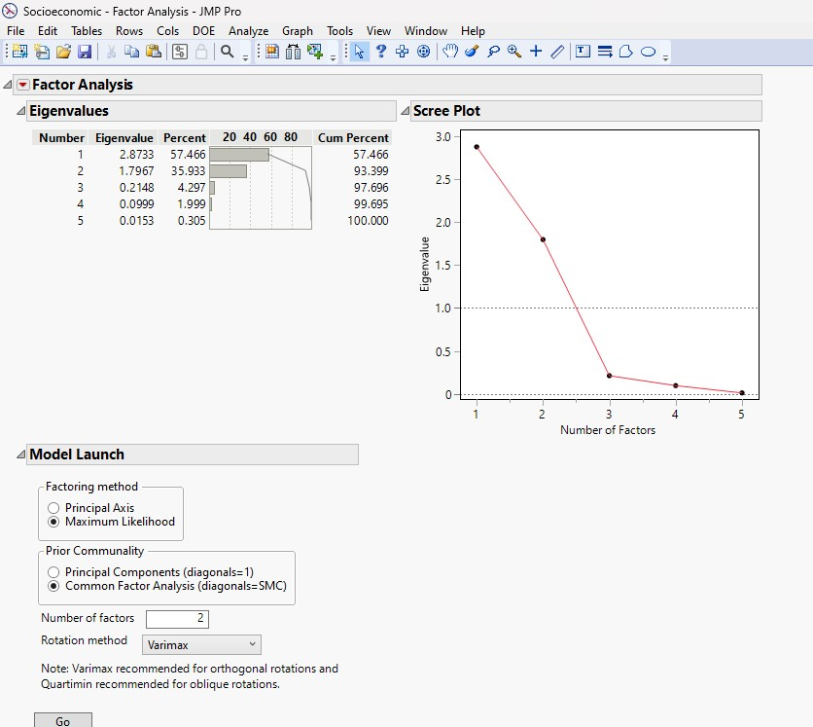

➔ **TO FIND DISCREMINANT**

STEP 1 :-CLICK ON ANALYSIS -> MULTIVARIATE METHODS ->DISCREMINANT

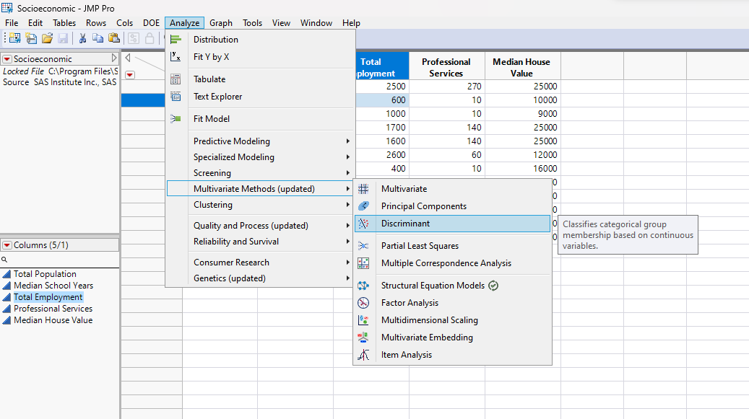

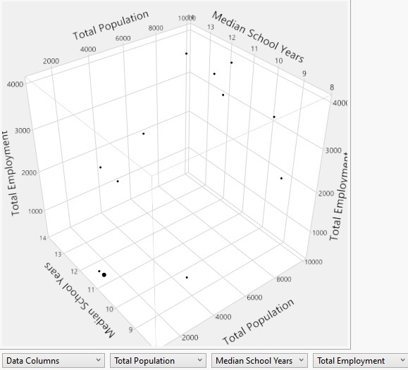

# ➔ STEPS TO GET PARTIAL LEAST SQUARE (PLS)

STEP 1 :- CLICK ON ANALYSE ->MULTIVARIATE METHODS -> PARTIAL LEAST SQUARE(PLS)

STEP 2 :- SELECT THE REQUIRED X AND Y VALUES FROM THE TABEL AND DROP THEM IN THE RESPECTIVE COLUMN

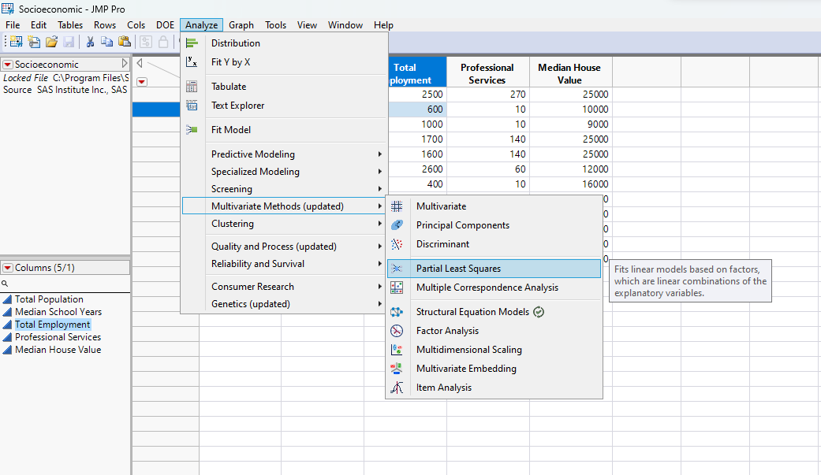

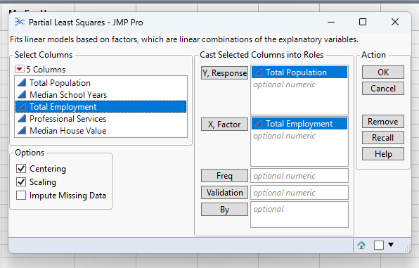

**PLS OUTPUT**

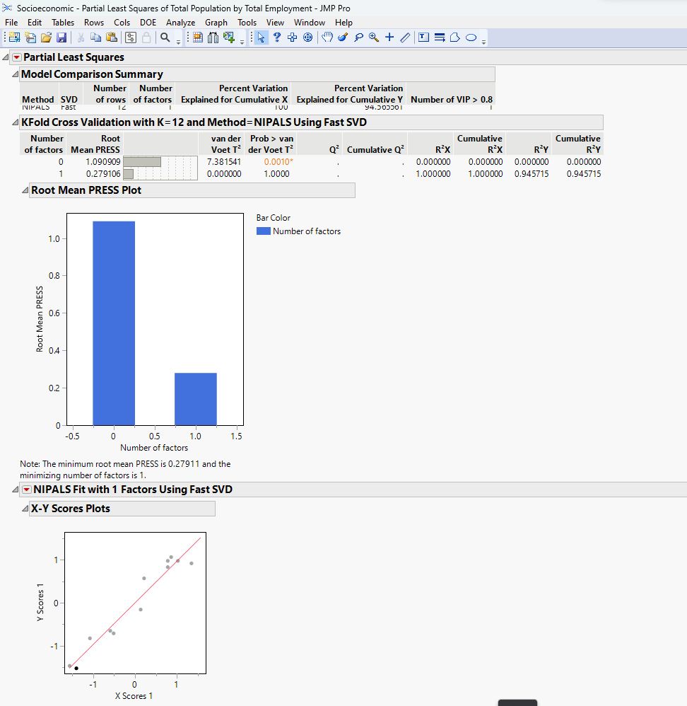

➔ **STEPS TO GET MULTIDIMENTIONAL SCALING (MDS)**

STEP 1 :- CLICK ON ANALYSE -> MULTIVARIATE METHODS -> MULTIDIMENTIONAL SCALING(MDS) STEP 2:- DRAG AND DROP THE POPULATION INTO Y AXIS TO GET THE OUTPUT

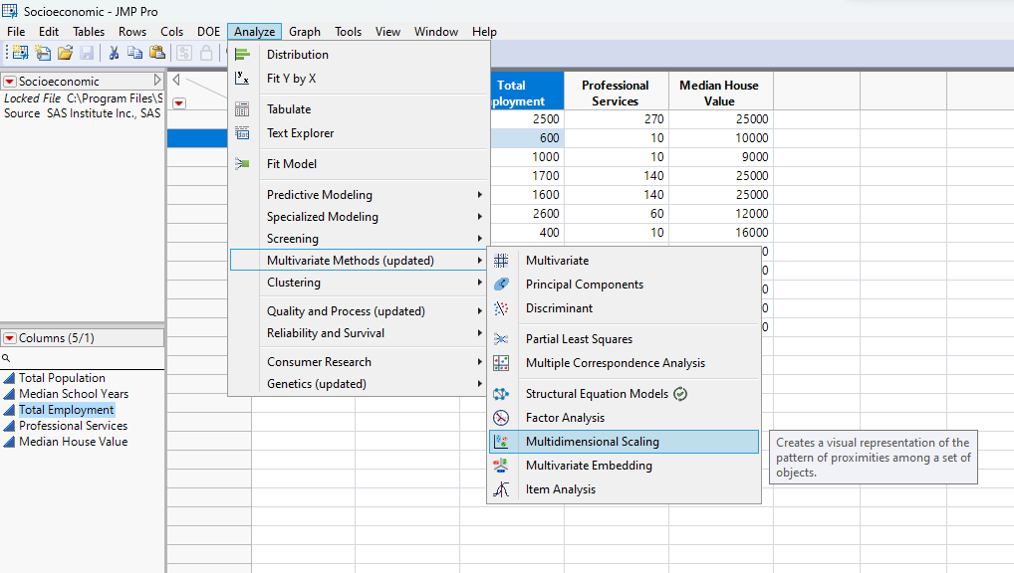



# OUTPUT FOR MDS

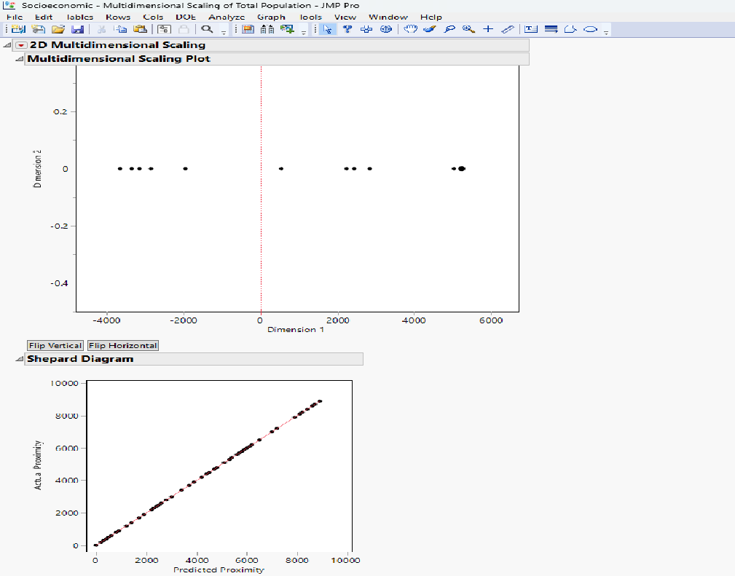

➔ **STEPS TO FIND STRUCTURAL EQUATION MODELS (SEM)**

STEP 1:- SELECT ANALYSE ->MULTIVARIATE METHODS ->STRUCTURAL EQUATION MODELS (SEM) STEP2 :-DRAG AND DROP THE POPULATION FROM THE TABLE INTO Y AXIS TO GET THE OUTPUT

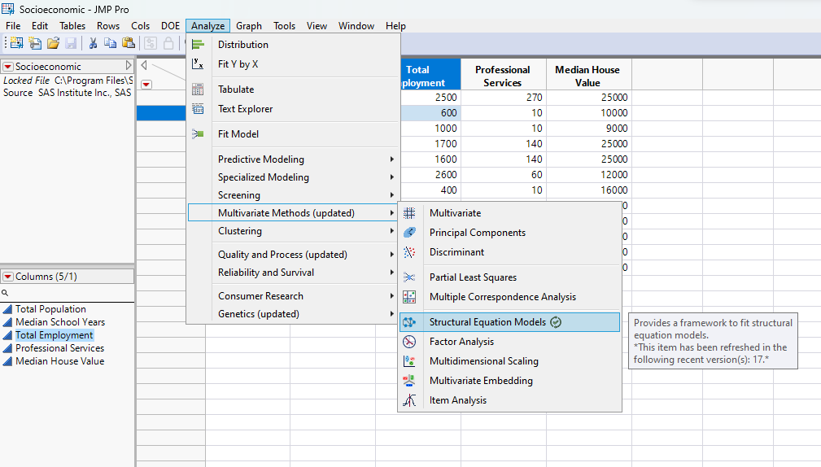

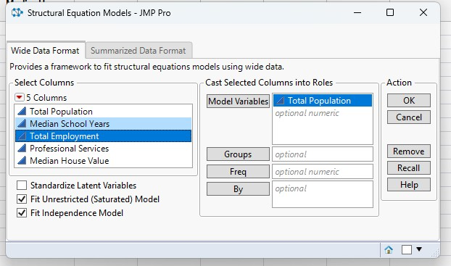

# OUTPUT FOR STRUCTURAL EQUATION MODELS

